. .

December 2021

# HR Review update Executive Summary



| mcmaster.ca

Date 2020  
Volume 1

## 

**Table of Contents**

**Context …………………………………………………….……………………………………….. 3**

HR Review Governance and Community Engagement ………………………..……………. 4

HR Review Recommendations ………………………………………………………………….. 4

Consolidation Table …………………………………………………………………...……….…. 5

**Foundational Projects ……………………………………………………………………….…. 6**

Position Management Project …………………………………….…………………………..... 6

Mosaic HR eForms Project …………………………………………………………………...… 7

**Ongoing Initiatives ……………………………………………………………………………... 8**

HR Service Delivery Model Initiative ………………………………………………………….. 8

FHS HR Transactional Process Initiative ……………………………………………………. 10

Hiring Process Improvement Initiative ………………………………………………….……. 10

**Moving Forward ………………………………………………………………………………... 11**

A Message From Wanda McKenna ……………………………………………………..….... 11



## Follow the links in this HR Review Executive Summary Report to access detailed information on the HR Review recommendations, objectives, and projects.

**A Message About This Report**

This HR Review Executive Summary report outlines the current status of HR Review projects and initiatives. It is not a stand-alone document as each section contains links to the HR Review website which is updated as work continues on various initiatives under the oversight and guidance of the AVP and CHRO Wanda McKenna.

In the two years since work started in November 2019 significant accomplishments have been made in building a strong foundation, most notable are the reconfiguration of PeopleSoft/Mosaic through the position management project which laid the groundwork for the Mosaic eForms project. The combination of these two projects resulted in the ability to ensure accuracy and efficiency in processes that impact payroll and HR and Finance reporting across the university. As well, changes to how HR services are

delivered including the focus on specialist roles in pay and benefits and the expansion of the HR Partner role in

Faculties and departments allowing for customized strategic and operational support to leaders across the university.

These accomplishments were achieved by the hard work and collaboration of the central HR team, the FHS HR team, many people across campus who have HR as part of their role, Kathy Clark and Kash Raza from the HR Review Project Management Office as well as the invaluable participation of the HR Review Working Group.

## **HR Review** **Governance and Community** **Engagement**

*For more information, visit the HR Review Website.*

Over the past two years, leaders from across McMaster University, all with a deep knowledge of HR administration within their Faculties and departments, provided input on the implementation and progress of the HR Review work.

The HR Review project governance structure was approved in January 2020, consisting of three groups: an HR Executive Committee comprised of the President and Vice Presidents plus Dr. J. Hurley representing the voice of the Deans, an HR Review Steering Committee, and the HR Review project management office.

[***Governance and Community Engagement***](https://hr-review.mcmaster.ca/)

[***7 Objectives***](https://hr-review.mcmaster.ca/objectives/)

**HR Review Recommendations**

The 20 HR Review recommendations were wide ranging and varied in complexity. Added to the 20 recommendations were several projects already underway within HR under the HR Digitization strategy. These were consolidated with the recommendations into 7 objectives, each with multiple action plans, and 2 foundational projects (see figure below).

**2019** 20 Report Recommendations + HR Digitization Projects

Consolidated into

**2020** 7 HR Review Objectives + 2 Foundational Projects

1. Payroll Workflow and Standard Operating Procedures
2. Payroll Metrics and Reporting
3. Staff Development
4. FHS/HR Service Centre – Responding to Unique FHS Requirements
5. Human Resources Functional Organization Design
6. Recruitment and Talent Acquisition
7. Update Pension and Benefits Plan Designs

**Foundational Project 2**

Replace HR Event Form with smart eForms

**Foundational Project 1**

Position Management – Mosaic Reconfiguration and Clean-up

**Foundational Project 2**

Replace HR Event Form with smart eForms

**Foundational Project 1**

Position Management – Mosaic Reconfiguration and Clean-up

## **Consolidation Table**

Click on the hyperlinks to visit the Recommendations and Objectives pages on the HR Review website.

|  |  |
| --- | --- |
| [**Related HR Review Recommendations**](https://hr-review.mcmaster.ca/recommendations/) | [**Related Objectives**](https://hr-review.mcmaster.ca/objectives/) |
| [#3, #20, #22](https://hr-review.mcmaster.ca/recommendations/) | [**Objective 1: Payroll Workflow and Standard Operating Procedures**](https://hr-review.mcmaster.ca/objectives/payroll-workflow-and-standard-operating-procedures/)  Develop or refine workflow, process charts and standard operating procedures (SOP) for all payroll and employee record maintenance tasks |
| [#1](https://hr-review.mcmaster.ca/recommendations/) | [**Objective 2: Payroll Metrics and Reporting**](https://hr-review.mcmaster.ca/objectives/payroll-metrics-and-reporting/)  Develop standard payroll accuracy metrics and reports to track and communicate results. |
| [#1, #4, #6](https://hr-review.mcmaster.ca/recommendations/) | [**Objective 3: Staff Development**](https://hr-review.mcmaster.ca/objectives/staff-development/)  Ensure all HR Service and Operations staff, as well as employees in faculties and departments who administer HR functions, have the knowledge, skills, and behaviours to deliver exceptional levels of accuracy and service. |
| [#11, #12, #13, #17](https://hr-review.mcmaster.ca/recommendations/) | [**Objective 4: FHS/HR Service Centre – Responding to Unique FHS Requirements**](https://hr-review.mcmaster.ca/objectives/respond-to-unique-fhs-requirements/)  FHS and central HR to identify the transactional work that is common across campus and determine where this work is best done from an efficiency (quantitative) and effectiveness (qualitative) perspective. |
| [#4, #8, #9, #10, #14, #17](https://hr-review.mcmaster.ca/recommendations/) | [**Objective 5: Human Resources Functional Organization Design**](https://hr-review.mcmaster.ca/objectives/human-resources-functional-organization-design/)  Develop a framework for determining where HR functions can most effectively be led and managed. Using process maps and measures, this framework will reflect where the greatest value is created. Value is determined using both quantitative and qualitative metrics which reflect the University’s mission, vision, and values  Clarification of distributed HR functions (decentralized) and pursuant processes, roles and structures need to be developed and approved. |
| [#15, #16, #18](https://hr-review.mcmaster.ca/recommendations/) | [**Objective 6: Recruitment and Talent Acquisition**](https://hr-review.mcmaster.ca/objectives/recruitment-and-talent-acquisition/)  Assess the current and desired state for recruitment and talent acquisition for both faculty and staff focusing on the importance of efficiency and effectiveness in attracting world class talent to McMaster.  Develop and implement plans to close the gap between current and desired states. |
| [#5, #7](https://hr-review.mcmaster.ca/recommendations/) | [**Objective 7: Update Pension and Benefits Plan Designs**](https://hr-review.mcmaster.ca/objectives/update-pension-and-benefits-plan-designs/)  Review and update McMaster's pension and benefits plan designs. Ensure they reflect current market practices and that there is a sustainable long-term plan to manage costs and service. |

## **Foundational Projects (Complete)**

In support of all 20 recommendations, 2 foundational projects (Position Management and Mosaic eForms) took immediate priority, i) reconfiguring the basic PeopleSoft/Mosaic approach to fully link positions to department budget tables improving accuracy in payroll, accounting, and headcount reporting and ii) introducing “smart eForms” supported by streamlined, standardized approval processes to increase efficiency and accuracy in payroll, hiring processes and HR reporting.

**Position Management Project (Foundational) Reconfiguration and Clean-up**

Workforce data is required for many purposes, including ensuring accuracy in payroll and benefits, managing security access to data, understanding the number of positions in each department for budgeting and reporting purposes, and administering software licencing. While many employees need workforce data access to do their job, employee personal data must at the same time be protected, secure, and available only to those who need access to confidential information to do their job.

To separate the data-driven position information from an employee’s personal information, PeopleSoft Mosaic uses a technical concept known as Position Management. It identifies a role within the organization by the associated attributes of that role, such as: job title, job code, salary band, reporting relationships, security access etc. An employee’s personal information is kept separate and can only be accessed by that employee, their direct manager as appropriate, and selected people with specific HR accountabilities who administer their pay, benefits and leave requirements.

In order to retain data integrity and security and enable accuracy within the payroll and employee record systems, the foundation of PeopleSoft/Mosaic needed to be reconfigured. This project, named “Position Management,” improved processes for creating and modifying positions - allowing ease of tracking, reporting and managing employee data, while opening up resources for planning and forecasting.

To ensure that the data remains accurate, department managers are encouraged to review position and job information on a regular basis, and annually review and

align their staffing profile and related position information to the upcoming budget period.

**Benefits of the Position Management approach include:**

* Improved accuracy in payroll by linking department budget tables and most benefit plans to the position thus preventing errors before they could occur (see Mosaic eForm project)
* Fully integrating with McMaster’s PeopleSoft Mosaic HR and Oracle Hyperion budget systems
* Streamlining processes for recruiting and hiring faculty and staff
* Providing organizational reporting by position which has been very valuable in COVID-19 and Back to McMaster planning
* Improving employee life cycle reporting, turnover analysis, and recruitment metrics.

The Position Management reconfiguration project created a strong, clean hierarchy and understanding of vacant-versus-filled positions that can be utilized for future planning, such as organizational charts, recruitment, talent development and succession planning.

The cleanup uncovered many positions that had invalid or incorrect budget centre information, resulting in incorrect data sent to payroll which in turn caused errors and delays in employee payments and tax records.

**20,000** employee records were reviewed and either confirmed as correct or corrections were made.

**6,000** positions that were vacant for at least 2 years were deactivated allowing for accuracy in headcount tracking.

*More   
information on Position Management can be found on the* [***HR Review Website***](https://hr-review.mcmaster.ca/completed-projects/position-management-project/)***.***

**Mosaic HR eForms Project (Foundational) Development and Bundle 1 Implementation**

The reconfiguration and significant database cleanup under the Position Management project set the groundwork to replace the paper-based HR Event Forms with Mosaic HR eForms.

HR Event forms are manual paper-based documents that administer every step in the employee life cycle. As with any manual, paper-based form, there were issues with accuracy, such as incorrect dates and pay rates; and timeliness, such as forms getting lost between departments, or forms not received in time for payroll cut-off dates. The most serious issues identified in the HR Review report regarding payroll were directly related to issues with the HR Event Forms.

*What was the Issue?*

Tens of thousands of employee-related transactional requests are made each year, ranging from creating a new position, to updating an employee’s assignment, to terminating or retiring the role. The paper-based HR Event Form caused many errors and delays due to multiple points of entry.

*What did we do?*

The project team simplified and improved the complex process, ultimately saving time and resources. Engagement with and feedback from employees across McMaster helped the project team transform the HR Event Form into an online self service. The new Mosaic HR eForms were designed to ensure that the correct information is being entered by the user before moving to the next step – decreasing errors, delay and re-work, and resulting in a quicker turnaround time.

*Outcome – Improving the Employee Experience*

The first two Mosaic eForms were launched on May 17, 2021:

* Request New Position eForm – to request new positions, and
* Request Position Data Update eForm – to update the attributes of existing positions

](https://hr-review.mcmaster.ca/ongoing-projects/mosaic-hr-eforms/)Check the [HR Review Website](https://hr-review.mcmaster.ca/) for the number of eForms processed since the launch and the average turnaround time from start to finish!

Additional new employee management-related eForms will launch to the McMaster community in January 2022.

Thanks to the cross-functional collaboration, engagement and feedback with many departments and Faculties across campus, the implementation has been met with great success. User feedback praised the ease and simplicity of the eForms, the comprehensive instruction guide and training videos, and the rapid responsiveness of the project team to mitigate any issues users experienced.

This is just the beginning of new ways of working. The strong foundation that has been built with both the introduction of eForms and new approach to position management will ensure stability in HR processes and technology resulting in increased accuracy, efficiency, and user satisfaction.



*More information on the Mosaic HR eForms can be found on the*

[***HR Review Website***](https://hr-review.mcmaster.ca/ongoing-projects/mosaic-hr-eforms/)***.***

[***New eForms and expected launch dates***](https://hr-review.mcmaster.ca/foundational-projects/mosaic-hr-eforms/)

**Ongoing Initiatives**

**HR Service Delivery Model Initiative**

The HR Review recommended improvement opportunities regarding the organization design and delivery of HR services in payroll and benefits, HR advisory services, talent acquisition, and the importance of a dedicated HR Business Partner role aligned with larger faculties and departments.

The HR Service Delivery Model was a critical part of the HR Strategic Plan 2016 -2020. In the Fall of 2019, the President and Vice-President’s group (PVP) granted directional agreement on the model to the CHRO, which aligned to the HR Review recommendations.

The new HR Service Delivery Model has four major, yet integrated, components:

1. HR Self-Service enables employees to review/update personal information and search for general HR information.
2. HR (‘HR Service Centre’) the *one stop shop* providing employees and managers with consistent general HR support and answering general HR inquiries.
3. HR Partners / HR Strategic Partners support senior leaders in Faculties/departments to provide HR strategic and operational advice and support. For inquiries, contact [hr.mcmaster@mcmaster.ca](mailto:hr.mcmaster@mcmaster.ca)
4. HR Centres of Expertise (CoE) provide oversight over policies, collective agreements, and act as the key driver of HR programs such as leadership development, wellness, and employee health and safety.

Specific to the HR Review recommendations, progress was made in realigning work within HR Operations, while adding subject matter expertise in payroll, tax compliance and analytics, expanding pension, benefits, and talent acquisition specializations within respective Centres of Expertise, and expanding the HR Strategic Partner role across the university.

**HR Staffing**

The HR Review focused on the need to have an HR organization design with sufficient numbers of HR professionals possessing the training and skills to ensure accuracy, efficiency and user satisfaction. The reviewers noted structural issues, such as unclear roles of responsibility between Central HR and FHS HR, that have existed for decades. Consistent themes emerged over the course of the review: a lack of standard operating procedures for many HR functions, a lack of role clarity both within HR and by the university community, and a lack of positional accountability for outcomes. On Page 2 the HR Review report notes “Stakeholders did not place blame on individuals and in fact there is sympathy for the staff in the Service Centre (SC) who were perceived to be working under extremely difficult circumstances.”

Specific recommendations were made regarding pay and benefits, the HR generalist role, FHS transactional work transfer to the HR Service Centre, talent acquisition and the introduction of an HR Business Partner role. Significant progress has been made in each of these areas, including staffing in the areas of HR Operations, Pension and Benefits, Transactional Work, Talent Acquisition and HR Strategic Partners. This work is expected to continue delivering an improved integrated OneHR support model for the University.

*More information on the HR Service Delivery Model Project can be found on the*

[***HR Review Website***](https://hr-review.mcmaster.ca/ongoing-projects/hr-service-delivery-model/)***.***

**HR Service Delivery Model**

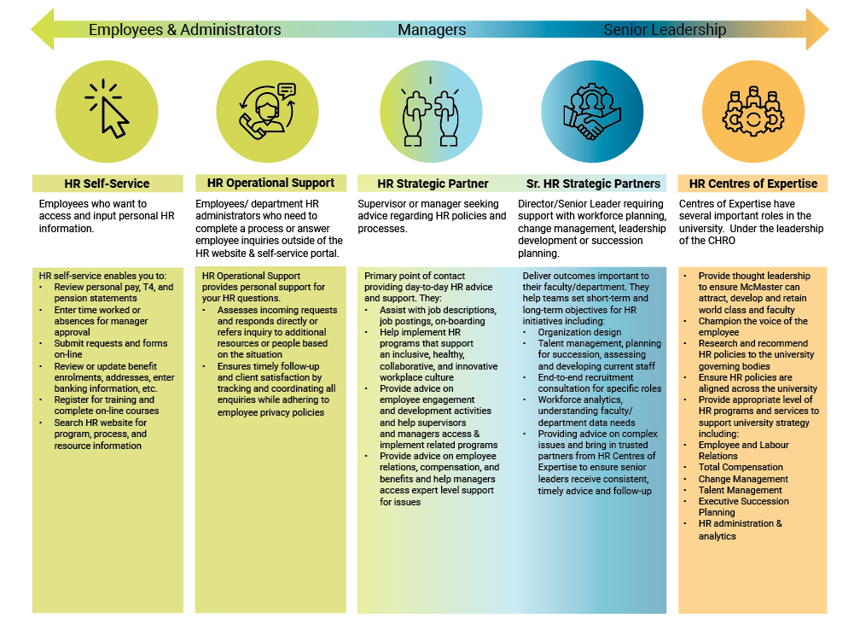

**FHS HR Transactional Process Initiative**

The Faculty of Health Sciences (FHS) is McMaster’s largest Faculty, employing over half of all University employees. It is unique as the only Canadian university that combines, in one Faculty, schools of medicine (including two regional campuses), nursing, rehabilitation science, and the programs of midwifery, Bachelor of Health Sciences, physician assistant and postgraduate health sciences education.

FHS is home to a multi-faceted workforce that encompasses clinical and non-clinical departments as well as health professional programs and schools, integrates with hospital networks and community clinical sites, and collaborates with organizations external to McMaster, including all levels of government. This complexity is enabled by a culture of flexibility and nimbleness and is supported by focused administrative units that work in collaboration with central campus.

With over 2,500 staff members, 900 full-time and 3,000 part-time faculty members, the Faculty thrives on its inter-professional and collaborative approach to healthcare and learning. As part of FHS’s continued pursuit of excellence to ensure the Faculty remains at the leading edge of health sciences education, it strives towards inter-professional collaboration, commitment to its communities, accountability and responsibility, innovation, excellence, integrity, respect, and optimism.

For an update on all the projects and initiatives related to this initiative click on the FHS Process Transition Plan link in the blue bubble!

**Hiring Process Improvement Initiative**

McMaster University is dedicated to attracting and selecting the right talent to position the University well for the future. The HR Review identified opportunities of improvement to become a world-class leader in best hiring practices and exceptional experiences for hiring managers, applicants, and candidates.

The pilot project involved the Faculty of Engineering and the Organizational Development, HR Operations and HR Project Management Office as they developed innovative ideas and collaborated to provide short and long-term improvements to the hiring process for TMG, Unifor Unit 1 and Interim employee groups.

Forty-one hiring process recommendations were identified to create an exceptional hiring experience while enriching the talent pool. Review the status in the link below!

*For more information, visit the HR Review Website.*



[***FHS Process Transition Plan***](https://hr-review.mcmaster.ca/ongoing-projects/fhs-hr-process-transition-plan/)

[***Hiring Process Improvement Initiative***](https://hr-review.mcmaster.ca/ongoing-projects/hiring-process-improvement-initiative/)

**Moving Forward**

**A Message from**

**Wanda McKenna,   
AVP and Chief Human Resources Officer**

I am pleased with the progress we have made and proud of the work done by HR team and those working across campus to respond to the recommendations of the HR Review Report.

HR will continue to collaborate with their partners across the McMaster community to build on the strong foundational work developed in response to the HR Review recommendations.

Transforming HR services across the university will continue as the key guiding mission of the HR team and the many people across the university who support HR activities as part of their role.

There is significant work still to be done to build upon the foundational benefits of both position management and Mosaic eForms, as these initiatives open up opportunities for further process and service improvements. As the newest bundle of eForms is launched in 2022, these forms become a part of everyday work for many administrators and leaders across the university enabling accuracy, process efficiency, improved user satisfaction for HR transactional work, and positively impacting the employee experience.

**Key Focus for 2022/23 Academic Year**

*Job Evaluation and Compensation*

The HR Review identified job evaluation for TMG as an issue. While this is true and a source of much frustration, it is a symptom of a larger organization design issue. As McMaster has evolved from a regional university to be recognized as a world class university, there is a need to help address perceived inequities between similar positions and ensure role clarity across a diverse university community. Within this are the external guidelines from provincial government regarding pay policies, which put more pressure on the job evaluation system. The job evaluation system itself could benefit from an assessment against other methodologies currently in the marketplace.

Going forward, it will be important to look at organization design as well as the supporting process of job evaluation as part of the bigger picture of total compensation. A strong business case and project plan will provide the rigour to accelerate results.

*HR Operational Excellence*

As McMaster embraces a commitment to operational excellence, it will be important that we continue to consider opportunities for administrative efficiency. Continued attention will be given to implementing standard, streamlined and user-friendly HR processes supported by technology solutions. An HR technology plan has been developed to ensure a long-term approach to technology that supports our operational excellence goals.

HR will continue to enhance its service model for employees and leaders, including improved self-service functionality and embedded expert HR support. Typical service centre technology support for issue tracking and analysis using some limited AI capabilities will be required to sustained increased volume and service levels.

Understanding the principles of “client ownership” as part of process and transaction management will help determine the degree of effective decentralization. Policies will need to be enhanced or developed to govern HR activities in a decentralized model.

*Human Resources Strategy*

Under our new HR Governance structure, an HR Executive Committee comprised of senior academic and administrative leaders will co-create a McMaster HR strategy in support of the university’s new vision and strategic priorities. The strategy will focus on programs to reinforce culture, building capabilities through individual contributor and leader development programs, managing the contributions of employees through performance metrics, and instilling change management practices that build alignment and engagement of employees to the university’s vision, values, and strategies.

*In closing,*

Human Resources programs and processes are important to the McMaster University community; including faculty and staff who have retired and people who want to join the community and build their careers. It takes not only HR colleagues but also leaders across the university, in collaboration with HR professionals, to ensure all employees feel engaged and can achieve their personal goals while contributing to the goals of the university.

For six consecutive years, McMaster has been recognized as one of Hamilton-Niagara’s Top Employers in Canada’s Top 100 Employers. While we are proud of our standing, we continuously strive for improvement and how we can be better.